5

ELASTICITY AND ITS APPLICATION

WHAT’S NEW IN THE SEVENTH EDITION:

There are no major changes to this chapter.

LEARNING OBJECTIVES:

By the end of this chapter, students should understand:

➢ the meaning of the elasticity of demand.

➢ what determines the elasticity of demand.

➢ the meaning of the elasticity of supply.

➢ what determines the elasticity of supply.

➢ the concept of elasticity in three very different markets (the market for wheat, the market for oil, and the market for illegal drugs).

CONTEXT AND PURPOSE:

Chapter 5 is the second chapter of a three-chapter sequence that deals with supply and demand and how markets work. Chapter 4 introduced supply and demand. Chapter 5 shows how much buyers and sellers respond to changes in market conditions. Chapter 6 will address the impact of government polices on competitive markets.
The purpose of Chapter 5 is to add precision to the supply-and-demand model. We introduce the concept of elasticity, which measures the responsiveness of buyers and sellers to changes in economic variables such as prices and income. The concept of elasticity allows us to make quantitative observations about the impact of changes in supply and demand on equilibrium prices and quantities.

KEY POINTS:

• The price elasticity of demand measures how much the quantity demanded responds to changes in the price. Demand tends to be more elastic if close substitutes are available, if the good is a luxury rather than a necessity, if the market is narrowly defined, or if buyers have substantial time to react to a price change.

• The price elasticity of demand is calculated as the percentage change in quantity demanded divided by the percentage change in price. If quantity demanded moves proportionately less than the price, then the elasticity is less than one, and demand is said to be inelastic. If quantity demanded moves proportionately more than the price, then the elasticity is greater than one, and demand is said to be elastic.

• Total revenue, the total amount paid for a good, equals the price of the good times the quantity sold. For inelastic demand curves, total revenue moves in the same direction as the price. For elastic demand curves, total revenue moves in the opposite direction as the price.

• The income elasticity of demand measures how much the quantity demanded responds to changes in consumers’ income. The cross-price elasticity of demand measures how much the quantity demanded of one good responds to the price of another good.

• The price elasticity of supply measures how much the quantity supplied responds to changes in the price. This elasticity often depends on the time horizon under consideration. In most markets, supply is more elastic in the long run than in the short run.

• The price elasticity of supply is calculated as the percentage change in quantity supplied divided by the percentage change in price. If quantity supplied moves proportionately less than the price, then the elasticity is less than one, and supply is said to be inelastic. If quantity supplied moves proportionately more than the price, then the elasticity is greater than one, and supply is said to be elastic.

• The tools of supply and demand can be applied in many different kinds of markets. This chapter uses them to analyze the market for wheat, the market for oil, and the market for illegal drugs.

CHAPTER OUTLINE:

I. The Elasticity of Demand

A. Definition of elasticity: a measure of the responsiveness of quantity demanded or quantity supplied to one of its determinants.

B. The Price Elasticity of Demand and Its Determinants

1. Definition of price elasticity of demand: a measure of how much the quantity demanded of a good responds to a change in the price of that good, computed as the percentage change in quantity demanded divided by the percentage change in price.

2. Determinants of the Price Elasticity of Demand

a. Availability of Close Substitutes: the more substitutes a good has, the more elastic its demand.

b. Necessities versus Luxuries: necessities are more price inelastic.

c. Definition of the market: narrowly defined markets (ice cream) have more elastic demand than broadly defined markets (food).

d. Time Horizon: goods tend to have more elastic demand over longer time horizons.

C. Computing the Price Elasticity of Demand

1. Formula

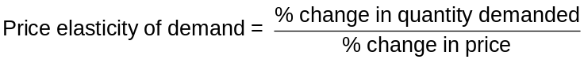


Work through a few elasticity calculations, starting with the example in the book. For principles of economics courses where there is no mathematical prerequisite, this may be difficult for some students. Working through a few simple examples will help to alleviate some of the students’ anxiety. Show every step of the algebra involved.

2. Example: the price of ice cream rises by 10% and quantity demanded falls by 20%.

Price elasticity of demand = (20%)/(10%) = 2

3. Because there is an inverse relationship between price and quantity demanded (the price of ice cream rose by 10% and the quantity demanded fell by 20%), the price elasticity of demand is sometimes reported as a negative number. We will ignore the minus sign and concentrate on the absolute value of the elasticity.


Students hate this! Explain that it really makes things easier and makes more sense because larger elasticities (in absolute value) imply greater sensitivity and responsiveness.

D. The Midpoint Method: A Better Way to Calculate Percentage Changes and Elasticities

1. Because we use percentage changes in calculating the price elasticity of demand, the elasticity calculated by going from one point to another on a demand curve will be different from an elasticity calculated by going from the second point to the first. This difference arises because the percentage changes are calculated using a different base.

a. A way around this problem is to use the midpoint method.

b. Using the midpoint method involves calculating the percentage change in either price or quantity demanded by dividing the change in the variable by the midpoint between the initial and final levels rather than by the initial level itself.

c. Example: the price rises from $4 to $6 and quantity demanded falls from 120 to 80.

% change in price = (6 − 4)/5 × 100 = 40%

% change in quantity demanded = (120 − 80)/100 x 100 = 40%

price elasticity of demand = 40/40 = 1

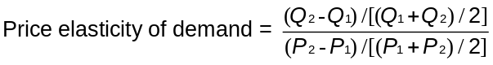

E. The Variety of Demand Curves
Figure 1

To clearly show the differences between relatively elastic and relatively inelastic demand curves, draw a graph on the board showing a relatively flat demand curve and one showing a relatively steep demand curve. Show that any given change in price will result in a larger change in quantity demanded if the demand curve is relatively flat. Use the same method when discussing the shape of the supply curve later in the chapter.

1. Classification of Elasticity

a. When the price elasticity of demand is greater than one, demand is defined to be elastic.

b. When the price elasticity of demand is less than one, the demand is defined to be inelastic.

c. When the price elasticity of demand is equal to one, the demand is said to have unit elasticity.

Activity 1—How the Ball Bounces

Type: In-class demonstration
Topics: Elastic, inelastic
Materials needed: One rubber ball and one “dead” ball. The “dead” ball is made of shock-absorbing material and doesn’t bounce. Museum stores and magic shops carry them.
Time: 1 minute
Class limitations: Works in any size class

Purpose
This quick, but memorable, demonstration can be used to introduce the concepts of elastic and inelastic.

Instructions
Bring two students to the front of the class. Give each of them a ball and ask them to bounce it off the floor and catch it. The student with the rubber ball can do this easily. The student with the “dead” ball will not be able to bounce it high enough to catch, no matter how hard he or she throws it.

Explain that one ball is elastic; it is responsive to change. The other ball is inelastic; it responds very little to change. These physical properties of elastic and inelastic are analogous to the economic concepts of elastic and inelastic.

2. In general, the flatter the demand curve that passes through a given point, the more elastic the demand.

3. Extreme Cases

a. When the price elasticity of demand is equal to zero, the demand is perfectly inelastic and is a vertical line.

b. When the price elasticity of demand is infinite, the demand is perfectly elastic and is a horizontal line.

Make sure that you provide several examples of goods with these types of demand curves. You may want to point out that students will see the perfectly elastic demand curve again when competitive firms are discussed.

4. FYI: A Few Elasticities from the Real World

F. Total Revenue and the Price Elasticity of Demand

Figure 2

1. Definition of total revenue: the amount paid by buyers and received by sellers of a good, computed as the price of the good times the quantity sold.

Another term for price times quantity is “total expenditure.” This term is sometimes used in questions found in the study guide and test bank. It is also important to point this out when discussing the market for illegal drugs at the end of the chapter.

Students find the relationship between changes in total revenue and elasticity difficult to understand. It may take several thorough discussions of this material before students will be able to master it.

2. If demand is inelastic, the percentage change in price will be greater than the percentage change in quantity demanded.

Figure 3

a. If price rises, quantity demanded falls, and total revenue will rise (because the increase in price will be larger than the decrease in quantity demanded).

b. If price falls, quantity demanded rises, and total revenue will fall (because the fall in price will be larger than the increase in quantity demanded).

3. If demand is elastic, the percentage change in quantity demanded will be greater than the percentage change in price.

a. If price rises, quantity demanded falls, and total revenue will fall (because the increase in price will be smaller than the decrease in quantity demanded).

b. If price falls, quantity demanded rises, and total revenue will rise (because the fall in price will be smaller than the increase in quantity demanded).

4. If demand is unit elastic, the percentage change in price will be equal to the percentage change in quantity demanded.

a. If price rises, quantity demanded falls, and total revenue will remain the same (because the increase in price will be equal to the decrease in quantity demanded).

b. If price falls, quantity demanded rises, and total revenue will remain the same (because the fall in price will be equal to the increase in quantity demanded).

Point out the usefulness of elasticity from a business owner’s point of view. Students should be able to see why a firm’s manager would want to know the elasticity of demand for the firm’s products.

G. Elasticity and Total Revenue along a Linear Demand Curve
Figure 4
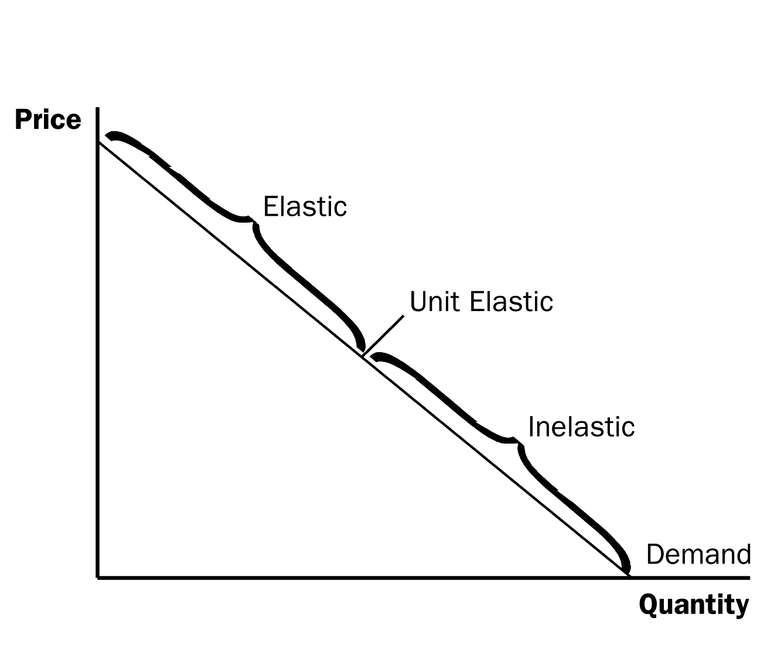
1. The slope of a linear demand curve is constant, but the elasticity is not.

a. At points with a low price and a high quantity demanded, demand is inelastic.

b. At points with a high price and a low quantity demanded, demand is elastic.

2. Total revenue also varies at each point along the demand curve.

Note that when demand is elastic and price falls, total revenue rises. Also point out that once demand is inelastic, any further decrease in price results in a decrease in total revenue.

H. Other Demand Elasticities

1. Definition of income elasticity of demand: a measure of how much the quantity demanded of a good responds to a change in consumers’ income, computed as the percentage change in quantity demanded divided by the percentage change in income.

a. Formula



b. Normal goods have positive income elasticities, while inferior goods have negative income elasticities.

ALTERNATIVE CLASSROOM EXAMPLE:
John’s income rises from $20,000 to $22,000 and the quantity of hamburger he buys each week falls from 2 pounds to 1 pound.

% change in quantity demanded = (1−2)/1.5 x 100 = -66.67%
% change in income = (22,000 −20,000)/21,000 x 100 = 9.52%
income elasticity = 66.67%/9.52% = -7.00

Point out that hamburger is an inferior good for John.

c. Necessities tend to have small income elasticities, while luxuries tend to have large income elasticities.

2. Definition of cross-price elasticity of demand: a measure of how much the quantity demanded of one good responds to a change in the price of another good, computed as the percentage change in the quantity demanded of the first good divided by the percentage change in the price of the second good.

a. Formula

b. Substitutes have positive cross-price elasticities, while complements have negative cross-price elasticities.

ALTERNATIVE CLASSROOM EXAMPLE:
The price of apples rises from $1.00 per pound to $1.50 per pound. As a result, the quantity of oranges demanded rises from 8,000 per week to 9,500.

% change in quantity of oranges demanded = (9,500 − 8,000)/8,750 x 100 = 17.14%
% change in price of apples = (1.50 − 1.00)/1.25 x 100 = 40%
cross-price elasticity = 17.14%/40% = 0.43

Because the cross-price elasticity is positive, the two goods are substitutes.

Make sure that you explain to students why the signs of the income elasticity and the cross-price elasticity matter. This will undoubtedly lead to some confusion because we ignore the sign of the own-price elasticity of demand. You may want to put together a table to present this distinction to students.

II. The Elasticity of Supply

A. The Price Elasticity of Supply and Its Determinants

1. Definition of price elasticity of supply: a measure of how much the quantity supplied of a good responds to a change in the price of that good, computed as the percentage change in quantity supplied divided by the percentage change in price.

2. Determinants of the Price Elasticity of Supply

a. Flexibility of sellers: goods that are somewhat fixed in supply (beachfront property) have inelastic supplies.

b. Time horizon: supply is usually more inelastic in the short run than in the long run.

B. Computing the Price Elasticity of Supply

1. Formula

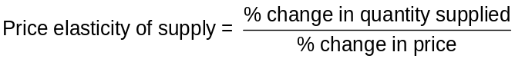

2. Example: the price of milk increases from $2.85 per gallon to $3.15 per gallon and the quantity supplied rises from 9,000 to 11,000 gallons per month.

% change in price = (3.15 – 2.85)/3.00 × 100 = 10%
% change in quantity supplied = (11,000 – 9,000)/10,000 × 100 = 20%
Price elasticity of supply = (20%)/(10%) = 2

C. The Variety of Supply Curves

Figure 5

1. In general, the flatter the supply curve that passes through a given point, the more elastic the supply.

2. Extreme Cases

a. When the elasticity is equal to zero, the supply is said to be perfectly inelastic and is a vertical line.

b. When the elasticity is infinite, the supply is said to be perfectly elastic and is a horizontal line.

3. Because firms often have a maximum capacity for production, the elasticity of supply may be very high at low levels of quantity supplied and very low at high levels of quantity supplied.

Figure 6

Again, you may want to present several examples of goods that may have supply curves like these.

III. Three Applications of Supply, Demand, and Elasticity

A. Can Good News for Farming Be Bad News for Farmers?

Figure 7

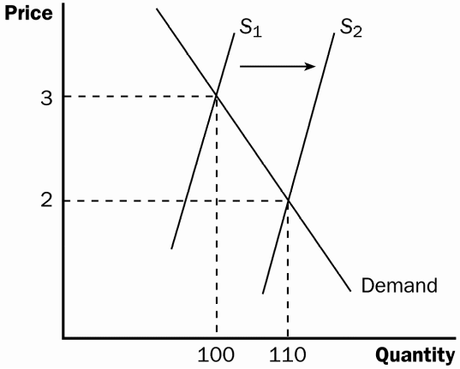
1. A new hybrid of wheat is developed that is more productive than those used in the past. What happens?

2. Supply increases, price falls, and quantity demanded rises.

3. If demand is inelastic, the fall in price is greater than the increase in quantity demanded and total revenue falls.

4. If demand is elastic, the fall in price is smaller than the rise in quantity demanded and total revenue rises.

5. In practice, the demand for basic foodstuffs (like wheat) is usually inelastic.

a. This means less revenue for farmers.

b. Because farmers are price takers, they still have the incentive to adopt the new hybrid so that they can produce and sell more wheat.

c. This may help explain why the number of farms has declined so dramatically over the past two centuries.

d. This may also explain why some government policies encourage farmers to decrease the amount of crops planted.

B. Why Did OPEC Fail to Keep the Price of Oil High?

Figure 8

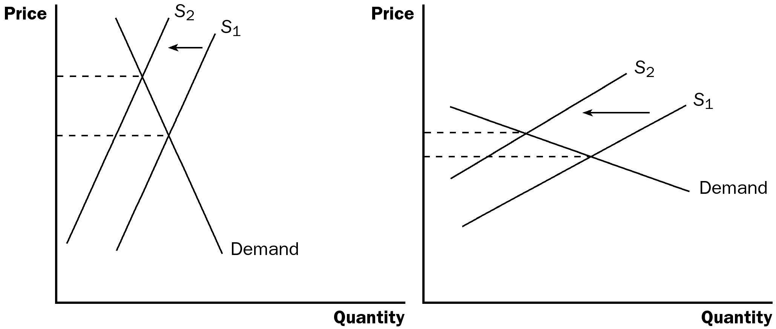
Short Run
Long Run

1. In the 1970s and 1980s, OPEC reduced the amount of oil it was willing to supply to world markets. The decrease in supply led to an increase in the price of oil and a decrease in quantity demanded. The increase in price was much larger in the short run than the long run. Why?

2. The demand and supply of oil are much more inelastic in the short run than the long run. The demand is more elastic in the long run because consumers can adjust to the higher price of oil by carpooling or buying a vehicle that gets better mileage. The supply is more elastic in the long run because non-OPEC producers will respond to the higher price of oil by producing more.

C. Does Drug Interdiction Increase or Decrease Drug-Related Crime?

1. The federal government increases the number of federal agents devoted to the war on drugs. What happens?

a. The supply of drugs decreases, which raises the price and leads to a reduction in quantity demanded. If demand is inelastic, total expenditure on drugs (equal to total revenue) will increase. If demand is elastic, total expenditure will fall.

b. Thus, because the demand for drugs is likely to be inelastic, drug-related crime may rise.

2. What happens if the government instead pursued a policy of drug education?

a. The demand for drugs decreases, which lowers price and quantity supplied. Total expenditure must fall (because both price and quantity fall).

b. Thus, drug education should not increase drug-related crime.
Figure 9
(a) Drug Interdiction
(b) Drug Education

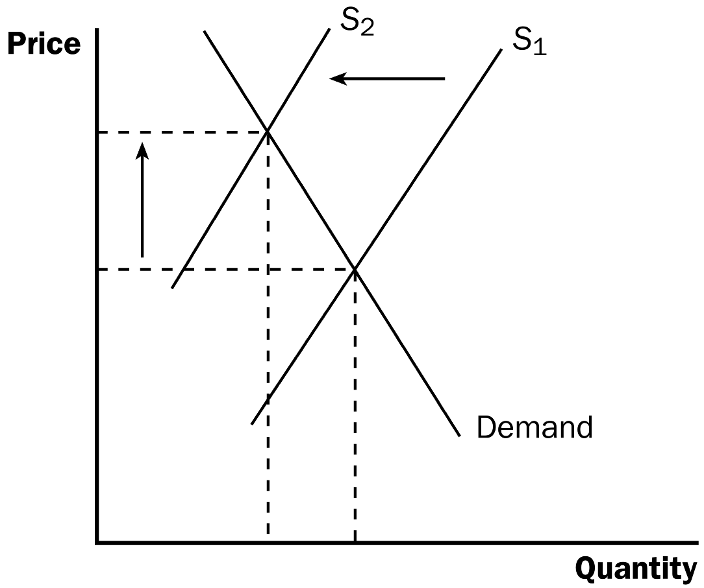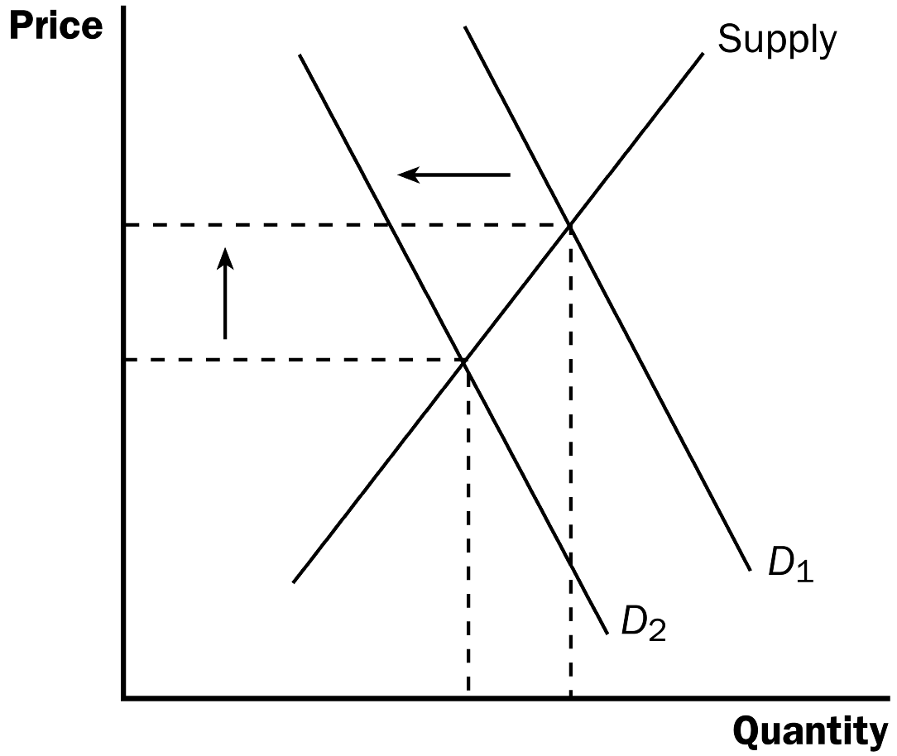

SOLUTIONS TO TEXT PROBLEMS:

Quick Quizzes

1. The price elasticity of demand is a measure of how much the quantity demanded of a good responds to a change in the price of that good, computed as the percentage change in quantity demanded divided by the percentage change in price.

When demand is inelastic (a price elasticity less than 1), a price increase raises total revenue, and a price decrease reduces total revenue. When demand is elastic (a price elasticity greater than 1), a price increase reduces total revenue, and a price decrease increases total revenue. When demand is unit elastic (a price elasticity equal to 1), a change in price does not affect total revenue.

2. The price elasticity of supply is a measure of how much the quantity supplied of a good responds to a change in the price of that good, computed as the percentage change in quantity supplied divided by the percentage change in price.

The price elasticity of supply might be different in the long run than in the short run because over short periods of time, firms cannot easily change the sizes of their factories to make more or less of a good. Thus, in the short run, the quantity supplied is not very responsive to the price. However, over longer periods, firms can build new factories, expand existing factories, close old factories, or they can enter or exit a market. So, in the long run, the quantity supplied can respond substantially to a change in price.

3. A drought that destroys half of all farm crops could be good for farmers (at least those unaffected by the drought) if the demand for the crops is inelastic. The shift to the left of the supply curve leads to a price increase that will raise total revenue if the price elasticity of demand is less than 1.

No one farmer would have an incentive to destroy her crops in the absence of a drought because she takes the market price as given. Only if all farmers destroyed a portion of their crops together, for example through a government program, would this plan work to make farmers better off.

Questions for Review

1. The price elasticity of demand measures how much quantity demanded responds to a change in price. The income elasticity of demand measures how much quantity demanded responds to changes in consumers' income.

2. The determinants of the price elasticity of demand include the availability of close substitutes, whether the good is a necessity or a luxury, the breadth of the definition of the market, and the time horizon. Goods with close substitutes have greater elasticities, luxury goods have greater price elasticities than necessities, goods in more narrowly defined markets have greater elasticities, and the elasticity of demand is greater the longer the time horizon.

3. An elasticity greater than one means that demand is elastic. When the elasticity is greater than one, the percentage change in quantity demanded exceeds the percentage change in price. When the elasticity equals zero, demand is perfectly inelastic. There is no change in quantity demanded when there is a change in price.

4. Figure 1 presents a supply-and-demand diagram, showing the equilibrium price, P, the equilibrium quantity, Q, and the total revenue received by producers. Total revenue equals the equilibrium price times the equilibrium quantity, which is the area of the rectangle shown in the figure.

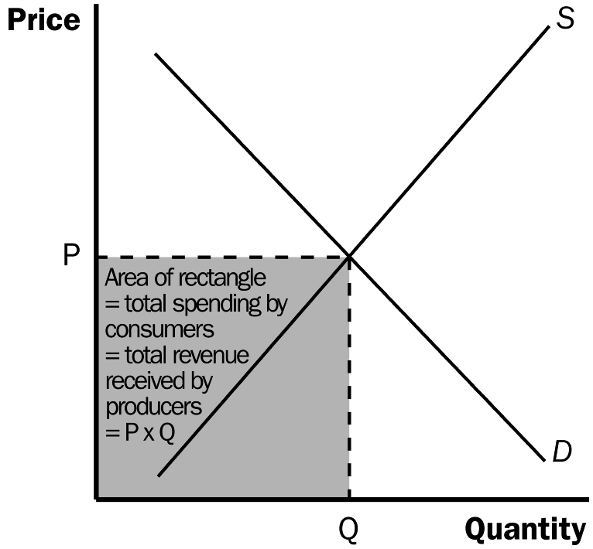

Figure 1

5. If demand is elastic, an increase in price reduces total revenue. With elastic demand, the quantity demanded falls by a greater percentage than the price rises. As a result, total revenue moves in the opposite direction as the price. Thus, if price rises, total revenue falls.

6. A good with income elasticity less than zero is called an inferior good because as income rises, the quantity demanded declines.

7. The price elasticity of supply is calculated as the percentage change in quantity supplied divided by the percentage change in price. It measures how much quantity supplied responds to changes in price.

8. If a fixed quantity of a good is available and no more can be made, the price elasticity of supply is zero. Regardless of the percentage change in price, there will be no change in the quantity supplied.

9. Destruction of half of the fava bean crop is more likely to hurt fava bean farmers if the demand for fava beans is very elastic. Destruction of half of the crop causes the supply curve to shift to the left resulting in a higher price of fava beans. When demand is very elastic, an increase in price leads to a decrease in total revenue because the decrease in quantity demanded outweighs the increase in price.

Quick Check Multiple Choice
1. a
2. b
3. d
4. c
5. a
6. c

Problems and Applications

1. a. Mystery novels have more elastic demand than required textbooks because mystery novels have close substitutes and are a luxury good, while required textbooks are a necessity with no close substitutes. If the price of mystery novels were to rise, readers could substitute other types of novels, or buy fewer novels altogether. But if the price of required textbooks were to rise, students would have little choice but to pay the higher price. Thus, the quantity demanded of required textbooks is less responsive to price than the quantity demanded of mystery novels.

b. Beethoven recordings have more elastic demand than classical music recordings in general. Beethoven recordings are a narrower market than classical music recordings, so it is easier to find close substitutes for them. If the price of Beethoven recordings were to rise, people could substitute other classical recordings, like Mozart. But if the price of all classical recordings were to rise, substitution would be more difficult. (A transition from classical music to rap is unlikely!) Thus, the quantity demanded of classical recordings is less responsive to price than the quantity demanded of Beethoven recordings.

c. Subway rides during the next five years have more elastic demand than subway rides during the next six months. Goods have a more elastic demand over longer time horizons. If the fare for a subway ride was to rise temporarily, consumers could not switch to other forms of transportation without great expense or great inconvenience. But if the fare for a subway ride was to remain high for a long time, people would gradually switch to alternative forms of transportation. As a result, the quantity demanded of subway rides during the next six months will be less responsive to changes in the price than the quantity demanded of subway rides during the next five years.

d. Root beer has more elastic demand than water. Root beer is a luxury with close substitutes, while water is a necessity with no close substitutes. If the price of water were to rise, consumers have little choice but to pay the higher price. But if the price of root beer were to rise, consumers could easily switch to other sodas or beverages. So the quantity demanded of root beer is more responsive to changes in price than the quantity demanded of water.

2. a. For business travelers, the price elasticity of demand when the price of tickets rises from $200 to $250 is [(2,000 – 1,900)/1,950]/[(250 – 200)/225] = 0.05/0.22 = 0.23. For vacationers, the price elasticity of demand when the price of tickets rises from $200 to $250 is [(800 – 600)/700] / [(250 – 200)/225] = 0.29/0.22 = 1.32.

b. The price elasticity of demand for vacationers is higher than the elasticity for business travelers because vacationers can choose a substitute more easily than business travelers. For example, vacationers can choose a different mode of transportation (like driving or taking the train), a different destination, a different departure date, and a different return date. They may also choose to not travel at all. Business travelers are less likely to do so because their schedules are less adaptable.

3. a. The percentage change in price is equal to (2.20 – 1.80)/2.00 x 100 = 20%. If the price elasticity of demand is 0.2, quantity demanded will fall by 4% in the short run [0.20 × 0.20]. If the price elasticity of demand is 0.7, quantity demanded will fall by 14% in the long run [0.7 × 0.2].

b. Over time, consumers can make adjustments to their homes by purchasing alternative heat sources such as natural gas or electric furnaces. Thus, they can respond more easily to the change in the price of heating oil in the long run than in the short run.

4. If quantity demanded fell, price must have increased according to the law of demand. For a price increase to increase total revenue, the percentage increase in the price must be greater than the percentage decline in quantity demanded. Therefore, demand is inelastic.

5. , a. The effect on the market for coffee beans is shown in Figure 2. When a hurricane destroys half of the crop, the supply of coffee beans decreases, the price of coffee beans increases, and the quantity decreases.
Quantity
Price
Figure 2
Demand
S₁
S₂

b. The effect on the market for cups of coffee is shown in Figure 2. When the price of coffee beans, an important input into the production of a cup of coffee, increases, the supply of cups of coffee decreases, the price of a cup of coffee increases, and the quantity decreases.

Because cups of coffee have an inelastic demand, when the price of a cup of coffee increases, the total expenditure on coffee increases.

c. The effect on the market for donuts is shown in Figure 3. When the price of coffee increases and the quantity demanded of coffee decreases, consumers demand fewer donuts because coffee and donuts are complements. When demand decreases, the price of donuts decreases.

Because donuts have an inelastic demand, when the price of donuts decreases, the total expenditure on donuts decreases.
Price
Supply

D₁
D₂

Figure 3

6. a. If your income is $10,000, your price elasticity of demand as the price of DVDs rises from $8 to $10 is [(40 – 32)/36]/[(10 – 8)/9] =0.22/0.22 = 1. If your income is $12,000, the elasticity is [(50 – 45)/47.5]/[(10 – 8)/9] = 0.11/0.22 = 0.5.

b. If the price is $12, your income elasticity of demand as your income increases from $10,000 to $12,000 is [(30 – 24)/27]/[(12,000 – 10,000)/11,000] = 0.22/0.18 = 1.22. If the price is $16, your income elasticity of demand as your income increases from $10,000 to $12,000 is [(12 – 8)/10]/[(12,000 – 10,000)/11,000] = 0.40/0.18 = 2.22.

7. a. If Maria always spends one-third of her income on clothing, then her income elasticity of clothing demand is one, because maintaining her clothing expenditures as a constant fraction of her income means the percentage change in her quantity of clothing must equal her percentage change in income.

b. Maria's price elasticity of clothing demand is also one, because every percentage point increase in the price of clothing would lead her to reduce her quantity purchased by the same percentage.

c. Because Maria spends a smaller proportion of her income on clothing, then for any given price, her quantity demanded will be lower. Thus, her demand curve has shifted to the left. Because she will again spend a constant fraction of her income on clothing, her income and price elasticities of demand remain one.

8. a. The percentage change in price (using the midpoint formula) is (1.50 – 1.25)/(1.375) × 100% = 18.18%. Therefore, the price elasticity of demand is 4.3/18.18 = 0.24, which is very elastic.

b. Because the demand is inelastic, the Transit Authority's revenue rises when the fare rises.

c. The elasticity estimate might be unreliable because it is only the first month after the fare increase. As time goes by, people may switch to other means of transportation in response to the price increase. So the elasticity may be larger in the long run than it is in the short run.

9. Walt's price elasticity of demand is zero, because he wants the same quantity regardless of the price. Jessie's price elasticity of demand is one, because he spends the same amount on gas, no matter what the price, which means his percentage change in quantity is equal to the percentage change in price.

10. a. With a price elasticity of demand of 0.4, reducing the quantity demanded of cigarettes by 20% requires a 50% increase in price, because 20/50 = 0.4. With the price of cigarettes currently $2, this would require an increase in the price to $3.33 a pack using the midpoint method (note that ($3.33 – $2)/$2.67 = .50).

b. The policy will have a larger effect five years from now than it does one year from now. The elasticity is larger in the long run, because it may take some time for people to reduce their cigarette usage. The habit of smoking is hard to break in the short run.

c. Because teenagers do not have as much income as adults, they are likely to have a higher price elasticity of demand. Also, adults are more likely to be addicted to cigarettes, making it more difficult to reduce their quantity demanded in response to a higher price.

11. To determine whether you should increase or decrease the price of admissions, you need to know if the demand is elastic or inelastic. If demand is elastic, a decline in the price of admissions will increase total revenue. If demand is inelastic, an increase in the price of admissions will cause total revenue to rise.

12. A worldwide drought could increase the total revenue of farmers if the price elasticity of demand for grain is inelastic. The drought reduces the supply of grain, but if demand is inelastic, the reduction of supply causes a large increase in price. Total farm revenue would rise as a result. If there is only a drought in Kansas, Kansas’ production is not a large enough proportion of the total farm product to have much impact on the price. As a result, price does not change (or changes by only a slight amount), while the output by Kansas farmers declines, thus reducing their income.

